International Research Journal of Engineering and Technology (IRJET) |  | e-ISSN: 2395-0056
Volume: 08 Issue: 05 | May 2021 | www.irjet.net | p-ISSN: 2395-0072
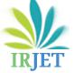

Customer Support Chatbot in Hindi Language

---------------------------------------------------------------------***----------------------------------------------------------------------

Abstract - As the number of services are increasing each passing day, the number of queries related to a particular service is also increasing rapidly. To provide solutions to these queries the companies are hiring a huge number of employees that can work as customer support. But this process of providing solution to the customers query is very slow for customer and expensive for company. To curb this problem there should be a solution feasible and accessible to everyone. The objective of our project is to provide solution to such problem. The proposed idea is to create a customer support chatbot that responds to the request made by the customer. The chatbot should be capable enough to interpret to all queries of the customers, analyze them and understand the intent of the queries. There are many different chatbots already present in the real time use but this one uses Hindi Language and voice communication. The proposed idea can be summarized as a customer supports chatbot that performs to accept customers query and to give appropriate solution in hindi language over voice communication.

1.INTRODUCTION

Chat bots or Virtual Assistants have been designed to simplify the interaction between computers and humans and have hit the market. A chat bot is a software that uses artificial intelligence (AI) that can converse (or chat) with a user in natural language via virtual chat rooms, websites, mobile apps and messaging applications or through the telephone. Chatbots are often referred to as one of the most promising and advanced form of interaction between machines and humans. Although, from a technological perspective, a chatbot can only represent the evolution of a Question Answering system based on Natural Language Processing (NLP). Generating responses to user queries in human like natural language is one of the most common examples of Natural Language Processing leveraging in various enterprises’ end-use applications. Chatbot applications slick interactions between services and people, improving customer experience. Simultaneously, chatbots offer companies various opportunities to enhance the customers loyalty and ensure operational efficiency by minimizing the surplus cost of customer service. Chatbot solutions have to effectively perform both of the tasks for

successful execution. Human support plays a vital role here: Irrespective of the kind of approach and the platform, human intervention plays a crucial role in training, optimizing and configuring the chatbot system. There are two different tasks which form the basis of a chatbot are User Request Analysis and Returning the response

1.1 User Request Analysis

This is the primary task that a chatbot performs. In this task, it analyses the users request and identifies the user intent in order to extract relevant entities.

This ability of identifying the user’s intent and extracting data and relevant entities present in the user’s request is the first and basic condition and the most crucial step at the core of a chatbot: If you fail to correctly acknowledge the user’s request, you will fail to provide the correct answer.

1.2 Returning the Response

First the user’s intent is identified and once that is done, the chatbot can provide the most appropriate response for the user’s query.

The answer can be:

- A predefined and generic text.

- A text retrieved from a knowledge database containing different answers.

- A contextualized piece of information that is user
data oriented. Data which is stored in enterprise systems.

- The result of an action that the chatbot has performed by interacting with backend applications.

A render question helps the chatbot to correctly understand the user’s request. Chatbot can be developed by the use of different approaches and tools. Depending on the application you want to address, some specific chat bot technologies are more suitable than others. In order to achieve the desired responses, the fusion of different AI forms such as machine learning, semantic understanding, and natural language processing may be the best option.

© 2021, IRJET | Impact Factor value: 7.529 | ISO 9001:2008 Certified Journal | Page 2853

International Research Journal of Engineering and Technology (IRJET) |  | e-ISSN: 2395-0056
Volume: 08 Issue: 05 | May 2021 | www.irjet.net | p-ISSN: 2395-0072

2. Literature Review

Customer satisfaction with a company’s services is often seen as the key to success and long-term competitiveness for a company. The industry such as Product Delivery, is getting a lot of attention as customer satisfaction. The technology platforms allow modelling the entire Product Delivery ecosystem with Artificial Intelligent (AI) to simulate scenarios of different economic, market and individual conditions. There is an increase in the demand for AI capabilities to interact with customers in benefits, insurance coverages and claims processes. Because it removes human factors and provides 24-hours service. In order to truly be effective and make business processes automated an alternate system is required. An advance dialogue system known as AI chatbot application system could automate the entire business processes. Thus, chatbot application system must have Natural Language Understanding (NLU) and Natural Language Processing (NLP) so that it can understand what customers are looking for. In the case of the Mutual funds insurance industry, chatbot can be used to answer basic questions, resolve insurance claims, sell products and make sure customers are properly covered by their insurance. AI chatbot can analyze data better than humans to more accurately predict each customer’s risk, thereby providing customers with the right amount of insurance and companies with protection from risky customers.
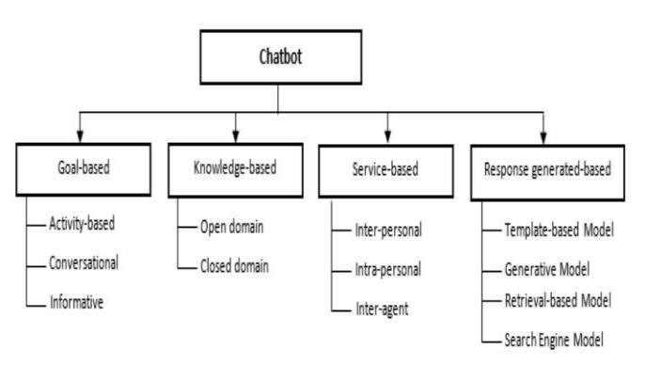

Figure 2.0: Taxonomy of Chatbot Application 3. Problem Statement and Objective

This project will consist of creating two important inter-dependent modules. They can be described as follows:

- Chatbot (based on NLP)

- Server ( Deep Learning model)
The Chatbot will be comprise of

- The chatbot will be build using NLP.

- It will have ability to communicate using voice.

  - To learn and understand the hindi language through NLP.
Server: (Deep Learning)

- Pre-process of the queries given by customer.

- Process it in ML, NLP engine to give the perfect solution to the customer.

- To learn and understand through ML, NLP engine.

- Scope & Overview

4.1 Justification:

In India, Around Lacs of queries are asked on daily basis in sectors like Telecommunication, Financial services, Banking, etc. For this, these sectors hire a huge number of employees to work as customer support and this increases the expenses of the companies. Most of the queries are common and repeated, keeping this in mind a use of chatbot will be very helpful for the companies to resolve similar queries and also this will help to save money. Also, there are multiple advantages of using chatbot as a support compared to Manual support systems like:

- 24/7 available.

- Instant communication.

- Reduced cost.

- Tailored solutions.

4.2 Product scope description:

- The product should be able to classify

query type and provide appropriate solutions.

- If new queries are raised the product
should redirect to support admin and Train itself for the query for future use.

4.3 Acceptance criteria:

- The product should be capable to provide solutions for queries of at least 3 sub-domains of mutual funds.

- The product should be able to identify that the query is related to its domain or not.

© 2021, IRJET | Impact Factor value: 7.529 | ISO 9001:2008 Certified Journal | Page 2854

International Research Journal of Engineering and Technology (IRJET) |  | e-ISSN: 2395-0056
Volume: 08 Issue: 05 | May 2021 | www.irjet.net | p-ISSN: 2395-0072

- All modules used to develop the bot should work synchronously.

- The interactions between the user and the product should be fast.

4.4 Deliverables:

- Segregation between queries related to product delivery domain and other domains.

- Identify the most asked query and train itself to provide much tailored solutions for the same query.

- Should redirect the user to support admin if bot is not able to provide solution of a query related to mutual funds domain.

4.5 Assumptions:

  - Server has NVIDIA GPU support.

  - TensorFlow GPU drivers are up-to-date.

  - Chatbot have been trained beforehand.

  - The Queries should be pre-defined

- Proposed System

This project will consist of creating two important inter-dependent modules. They can be described as follows:

- Chatbot (based on NLP)

- Server (Deep Learning model)
The Chatbot will be comprise of

  - The chatbot will be build using NLP.

  - To learn and understand through NLP.
Server: (DeepLearning Phase)

- Preprocess of the queries given by customer.

- Process it in ML, NLP engine to give the perfect solution to the customer.

3. To learn and understand through ML, NLP engine.

5.1 Analysis/Framework/Algorithm

TensorFlow: It is the fastest and simplest way to do image recognition on your laptop or computer without any GPU because it is just an API and your CPU is good enough for this. TensorFlow provides the opportunity to adapt a pre-trained model to new classes of data with several advantages.

Flask: is a micro web framework written in Python. It is classified as a microframework because it does not require particular tools or libraries. It has no database abstraction layer, form validation, or any other components where pre-existing third-party libraries provide common functions.

HTML, CSS and JavaScript: Useful for front end development and building user interfaces or UI components.

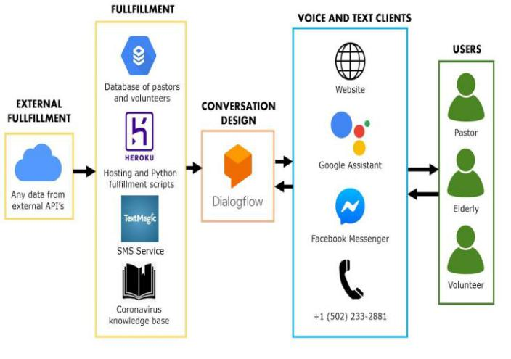

Figure 5.1: Framework for Chatbot

© 2021, IRJET | Impact Factor value: 7.529 | ISO 9001:2008 Certified Journal | Page 2855

International Research Journal of Engineering and Technology (IRJET) |  | e-ISSN: 2395-0056
Volume: 08 Issue: 05 | May 2021 | www.irjet.net | p-ISSN: 2395-0072

NLP (Natural Language processing):

Natural language processing is a subfield of linguistics, computer science, and artificial intelligence concerned with the interactions between computers and human language, in particular how to program computers to process and analyze large amounts of natural language data

6. Design Details

The given flowchart will explain the working of project in the easiest and the simplest way:
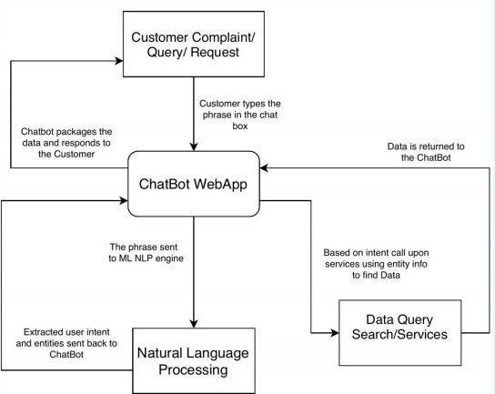

Figure 6: Flowchart

Step 1: Accepting Users Query.

The Chatbot will accept any user’s Query.

Step 2: Analyzing the Query.

The Chatbot will analyze the user’s asked query and check for the most appropriate solution for it in the Database.

Step 3: Reply to Query.

The Chatbot will provide solution to the user’s query after being trained on the given data.

6.1 Use Case Diagram

A use case diagram at its simplest is a representation of a user's interaction with the system that shows the relationship between the user and the different use cases in which the user is involved
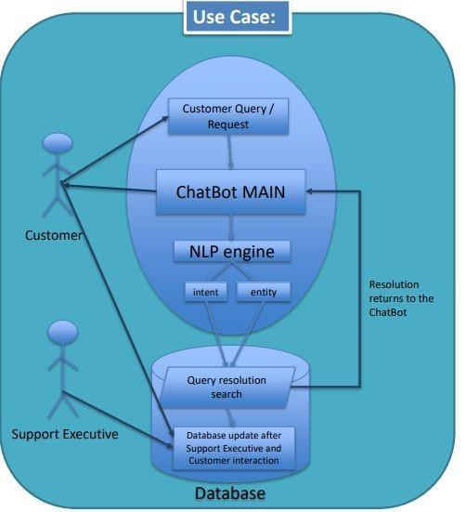

Figure 6.1: Use Case Diagram

Table -1: Requirements Table

 | Details of Hardware and Software
 | Operating System | Windows 7/8/8.1/10,
 |  | Linux
 |  | VS | Code,
 | Tools and Framework | TensorFlow, | Flask,
 |  | HTML, CSS and JavaScript.
 | Language Requirement | Python, JavaScript
 | Server | Locally hosted
 |  | Server
7. CONCLUSIONS

In this semester we have created prototype of project along with software and framework analysis report to build customer support chatbot. The query can

© 2021, IRJET | Impact Factor value: 7.529 | ISO 9001:2008 Certified Journal | Page 2856

International Research Journal of Engineering and Technology (IRJET) |  | e-ISSN: 2395-0056
Volume: 08 Issue: 05 | May 2021 | www.irjet.net | p-ISSN: 2395-0072

be further processed to detect query type inserted by user and provide optimal solution for it. The chatbot will contain most of the queries related to product delivery and try to provide solution for the user’s query as fast as it can. The chatbot will use new queries that is not known by the chatbot to train itself with the help of NLP.

8. ACKNOWLEDGEMENT

We wish to express our sincere thanks to our director Dr. Mohiuddin Ahmed and our principal Dr. Ganesh Kame, M.H. Saboo Siddik College of Engineering for providing us all the facilities, support, and wonderful environment to meet our project requirements.

We would also take the opportunity to express our humble gratitude to our Head of the Department of Computer Engineering Dr. Zainab Pirani for supporting using all aspects and for encouraging us with her valuable suggestions to make our project successful. We are highly thankful to our mentor and guide Prof. Anand Bali whose valuable guidance helped us understand the project better, his constant guidance and willingness to share his vast knowledge made us understand this project and its manifestations in great depth and helped us to complete the project successfully. We would also like to acknowledge with much appreciation the role of the staff of the Computer Department, especially the Laboratory staff, who permitted them to use the labs when needed and the necessary material to complete the project.

We Appreciate and show our gratitude and guidance given by other supervisors and project guides, their comments and tips helped us in improving our presentation skills.

9. REFERENCES

- Dialogflow Documentation | Google Cloud https://cloud.google.com/dialogflow/docs

- R Khan, A Das - A complete guide to getting started with chatbots, 2018 – Springer

- Evaluating and informing the design of chatbots

M Jain, P Kumar, R Kota, SN Patel - Proceedings of the

2018 Designing …, 2018 - dl.acm.org

- Chatbots for learning: A review of educational chatbots for the Facebook Messenger

P Smutny, P Schreiberova - Computers & Education, 2020-Elsevierhttps://www.youtube.com/watch?v=38sL6pAD Cog

- Chatbots and conversational interfaces: Three domains of use

S Di Gaetano, P Diliberto - Fifth International Workshop on Cultures of …, 2018 - ceur-ws.org

- A Psychologist Chatbot Developing Experience - CEUR-WS.org

- Methodology for the Implementation of Virtual Assistants for Education Using Google Dialogflow https://www.researchgate.net/publication/336827160 _Methodology_for_the_Implementation_of_Virtual_Assist ants_for_Education_Using_Google_Dialogflow

10. BIOGRAPHIES

I’m Masood Khan, a CSE under-grad at MHSSCOE, my specialized domains include ML and Chatbot based technologies.


I’m Anas Khan, a Computer

Engineering under-graduate at
MHSSCOE, profound in Machine

Learning and AI.


I’m Rakesh Utekar, a Computer Engineering Student at MHSSCOE, I like to optimize and practice AI & ML.

© 2021, IRJET | Impact Factor value: 7.529 | ISO 9001:2008 Certified Journal | Page 2857

